Meeting Notice and Agenda
Town Board of Trustees
Regular Meeting
February 6, 2024 – 6:30 pm
Mounds Community Building
15 W 14th Street, Mounds OK 74047

1. Call to Order

2. Roll Call

3. Consent Agenda (A-K)
All matters listed under “Consent” are considered by the Town Board to be routine and will be enacted by one motion. Any Trustee, however, can remove an item from the Consent Agenda by request.

A. Approval of the Minutes for the January 16, 2024, Regular meeting and January 25, 2024, Special meeting.
B. Approval of the Library report
C. Approval of the Police report
D. Approval of the Fire report
E. Approval of the Financial report
F. Approval of the Budget report
G. Approval of the Court report
H. Approval of Purchase Orders for Streets & Alleys and Parks Departments
I. Building Inspector Report
J. Approval of the Purchase Orders for General Government, Streets & Alleys, and
Court Fund

4. Court Fees & Costs
Discuss, consider, and take possible action on court fees and costs.

5. Faith Family Integrity Team
Discuss, consider, and take possible action on FFIT options for the town’s management and resources.

6. Executive Session

The Trustees will consider retiring into Executive Session for the purpose of discussion for item A. related to the employment, hiring, appointment, promotion, demotion of individual salaried (Streets & Alleys personnel, office clerk, and librarian) making permanent for benefit purposes in accordance with O.S. Title 25, Section 307(B)(1).

- Trustees will consider and take any action deemed appropriate to Streets & Alley Personnel, office clerk and librarian.

7. Adjournment

This Agenda was filed in the office of the Town Clerk and posted at 6 PM on February 5, 2024, at the Mounds Municipal Building located at 1319 Commercial Avenue, Mounds, OK 74047 and the Mounds Community Building located at 15 W 14th Street in Mounds, OK 74047, by Town Clerk Kristin Haddock.

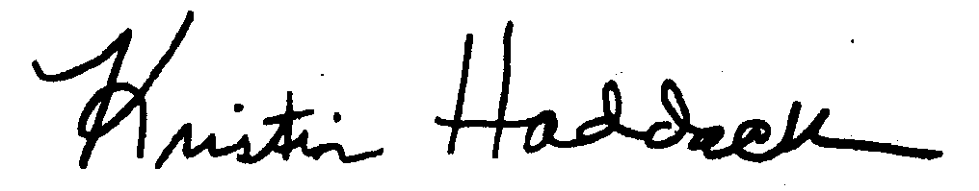
Kristin Haddock, Town Clerk

