Meeting Notice and Agenda
Town Board of Trustees
Regular Meeting
March 12, 2024 – 6:30 pm
Mounds Community Building
15 W 14th Street, Mounds OK 74047

1. Call to Order

2. Roll Call

3. Consent Agenda (A-K)
All matters listed under “Consent” are considered by the Town Board to be routine and will be enacted by one motion. Any Trustee, however, can remove an item from the Consent Agenda by request.

A. Approval of the Minutes for the December 5, 2023, Regular meeting
B. Approval of the Library report
C. Approval of the Police report
D. Approval of the Fire report
E. Approval of the Financial report
F. Approval of the Budget report
G. Approval of the Court report
H. Approval of Purchase Orders for Streets & Alleys and Parks Departments
I. Building Inspector Report
J. Approval of the Purchase Orders for General Government, Streets & Alleys, and
Court Fund
K. 901 Bland Sewer Adjustment – Patrick Swan

4. Citizen of the Month Presentation

5. Resolution 20240312
Discuss, consider, and take possible action declaring April as Fair Housing Month.

6. Car Show
Discuss, consider, and take possible action on approving the Car Show for October 5, 2024.

7. Budget Calendar
Discuss, consider, and take possible action on the 2024-2025 Budget Calendar

8. Proposed Revenue Budget
Discuss, consider, and take possible action on 2024-2025 proposed revenue budget.

9. Budget Amendments
Discuss, consider, and take possible action on Budget Amendments
.

10. Court Fees & Costs
Discuss, consider, and take possible action on reviewing the impact of HB 2259 on court operations and discuss, consider, and take possible action on court fees and costs.

11. Police Department
Discuss, consider, and take possible action on modifying the Police Department Budget

12. Reserve Classification
Discuss, consider, and take possible action on adding a reserve classification to the employee handbook.

14. Gary Tersiner
Hear complaint of lack enforcement of ordinances.

15. Faith Family Integrity Team
Discuss, consider, and take possible action on contract presented by Faith Family Integrity Team

16. City Hall
Discuss, consider, and take possible action on City Hall renovations, remodel, or design.

17. Adjournment
This Agenda was filed in the office of the Town Clerk and posted at 6 PM March, at the Mounds Municipal Building located at 1319 Commercial Avenue, Mounds, OK 74047 and the Mounds Community Building located at 15 W 14th Street in Mounds, OK 74047, by Town Clerk Kristin Haddock.

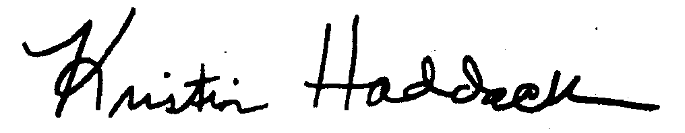
Kristin Haddock, Town Clerk

City Hall

